







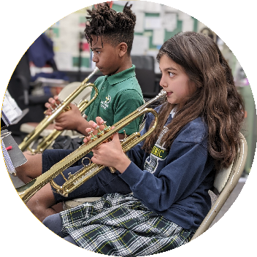








Rejoice!

Sunday
Catholic Schools Week 2026
January 25-31

WHO WE ARE

Catholic Education aims not only to communicate facts but also to transmit a coherent comprehensive vision of life... - St. Pope John Paul II
- All school Mass celebrated at your parish, followed by a donut & coffee bar; invite school benefactors to attend
- Share content (photos/videos) of how your school teaches & practices our Catholic faith

WHAT WE LOVE

Whatever you do, whether in word or deed, do it all in the name of the Lord Jesus, giving thanks to God the Father through Him. - Colossians 3:17
- Dress down day for all club members; wear your club spiritwear
- Host club information fair during lunch to showcase school opportunities for extracurricular enrichment
- Share content (photos/videos) of club/extracurricular opportunities at your school

Monday

Tuesday

HOW WE EXCEL

The more I study nature, the more I stand amazed at the work of the Creator. Science brings men nearer to God. - Louis Pasteur
- Dress like a scientist, inventor, explorer, or adventurer
- Assign a different Catholic scientist, inventor, engineer, or creator to each grade level. Task each grade with creating a digital or traditional poster highlighting the life and works of that person. Display these creations for all to see.
- Share content (photos/videos) highlighting high-quality, contemporary learning, and educational achievements

HOW WE INSPIRE

Through his artistic creativity, man appears more than ever in the image of God.
- St. Pope John Paul II
- Dress down for all actors/actresses and students who produced award-winning visual art
- Create a slideshow or collage, to be posted throughout the building that showcase your visual and performing arts accomplishments over the past year
- Share this content (slideshow or collage)

Wednesday

Thursday

HOW WE COMPETE

Sports is one of those universal languages that overcomes cultural, social, religious, and physical differences and manages to unite people. - Pope Francis
- Dress down day for all CYO athletes who wear their jersey or sport speciﬁc spiritwear
- Write thank you cards to CYO coaches, record a video message of gratitude, etc.
- Share content (photos/videos) showcasing your CYO athletes, sports, and athletic community

WHERE WE SERVE

Remember that the Christian life is one of action ... Let there be few words and many deeds, and let them be done well. - St. Vincent Pallotti
- School-wide spiritwear dress down day for the entire school community
- Showcase, via photos, videos, service fair, etc. the many ways your students, families, and school community support one another, the parish, and their community at large
- Share content (photos/videos) showcasing student/school service projects in support of the community and parish

WHEN WE INVEST

Friday

Saturday

O God, grant that whatever good things I have, I may share generously with those who have not ... - St. Thomas Aquinas
- Encourage each child to secure two Angel Scholarship Fund Referrals (grandma, grandpa, aunt, uncle, mom, dad, family friend, older sibling, godparent, parent's coworker, etc.); faculty/staff members submit their Angel Scholarship Fund donation
- Return donation referral forms to school; create a contest, dress down week, etc. for 100% school participation
- Share joyful content (photos/videos) of school community showcasing belonging, gratitude, and care for one another

