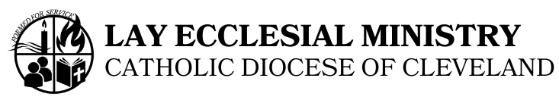

Procedure For Application to the Lay Ecclesial Ministry Process

Application Checklist:

1) Complete Application Form
2) Vision of Ministry
In a brief essay (1-2 pages) please describe your understanding of ministry
in the church.
3) Faith Life Autobiography
Briefly, (3-5 pages) describe your faith/life journey and how you have come
to this point in your life where you are interested in committing yourself to
the Church in ministry.
4) References: Personal: name:__________________________
Personal: name:__________________________
Personal: name:__________________________
Business: name:__________________________
Pastor: name:_____________________________
spouse or religious community expressing
support and awareness (if applicable)

5) Sacramental Records: Request a copy from the church of baptism to
be sent directly to our office] Baptismal Certificate with notations
of First Eucharist, Confirmation and Marriage certificates.
6) Transcript(s) of high school and/or college records.
7) Arrange for criminal background check, if not already registered with
Solution.com.
________ 9) $75.00 Application Fee (Payable to: Catholic Diocese of Cleveland)

Although applications are received throughout the year, the final deadline for accepting applications for a new formation year is May 2:

Mail all materials to: Attention: Michelle Nowak, Director Lay Ecclesial Ministry Office
28700 Euclid Avenue
Wickliffe, OH 44092
Advisory Board Interviews
After all of your application materials have been received, you will be notified of the date, time and place of your interview. You will be interviewed by a staff member of the Lay Ecclesial Ministry Office and two or three Advisory Board members.
Summer: Orientations
Ensuing acceptance into the process, Orientation is scheduled during the summer.
Attendance is required at both days of orientation.

