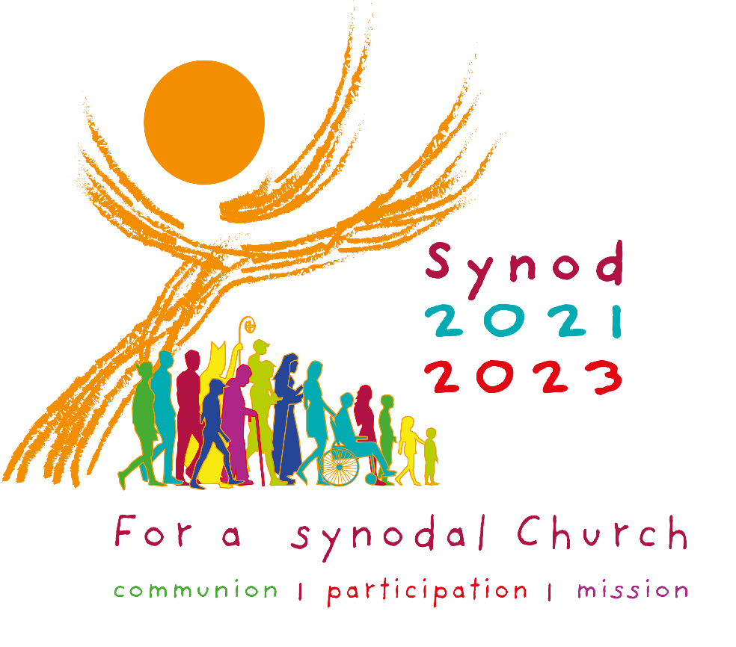

Catholic Diocese of Cleveland
Elementary School Lesson Plan for Catholic School & Parish School of Religion

Learning Outcomes

The students will be able to
- Participate in giving input to share with the Diocese for the Synod on Synodality
- Begin to understand what it means to be Church in the Synodal way
- Experience sharing their faith and stories
- Understand the role of the Holy Spirit in guiding them and the Church
- Share their experience of Church and their hopes for the Church
- Experience praying an Examen, through guided meditation
- Begin to develop a sense of the bigger picture of the Church and being part of it.
Key Terms
- Church – the people of God, the faithful including ordained, religious, and laity
- Church Family – those with whom we live our life of faith, particularly our Catholic family
- Family of Faith – those with whom we share in the life of Christ
- Synod – a formal journey of faith together in the Catholic Church
- Examen – a reflective prayer that invites a conversation with God to examine our lives

Key Points

- Church is family.
- Church is being together and celebrating our faith.
- We are connected by Church and by God.
- Church is everywhere; it is the people of God
- Synod is a way of being a church and the People of God
- As church, we journey together
- As Church we are led by the Holy Spirit
- When we are church this way, we are the best church
- Everyone’s voice matters. God wants to hear from all people.
Resources
- Preparatory Document: For a Synodal Church: Communion, Participation, Mission https://www.synod.va/en/news/preparatory-document.html
- YouTube Video Resources
- What is the Synod of Bishops?
By Rome Reports in English (1 minute 50 seconds)
https://youtu.be/fvLjDmCh6Sk
- What is a Synod? - The basics
By The Vatican in preparation for the Synod of Bishops on the Family in 2014-15 (5 minutes 9 seconds) https://youtu.be/_Z8h7ap2jrQ
Materials

- Elementary Synod Lesson PowerPoint (or photos of a church building, an empty church, a full church, and photos of a group of people doing things that could be considered church, such as praying, choir, working together)
- Art supplies, if being used
- Pens and paper for students to make notes
- A Report Form for each class
- Prayer Cards, if being used
  - Examen Prayer Card free to download at https://www.ignatianspirituality.com/examen-prayer-card/
  - Holy Spirit Prayer Card (in PowerPoint)

Art/Creative Activity Options for Sharing and Listening Section

Because children often express themselves better or easier through artwork or writing, each teacher/catechist/leader is encouraged to use art or composition during the listening activity. Some examples are provided, but you are encouraged to be creative based on the children in your group. Different grade levels in the same school or parish may use different approaches.

- Have each group or each student create a poster with the answers to the questions. Answers could be words, drawings, collage, etc. For children who are not yet able to write well, that is, younger children, an adult or teen volunteer may be enlisted to help add descriptions to artwork as needed or to record the thoughts of the younger children.
- Create a paper chain or tree of thanks or church building using paper links, leaves, or building blocks with individual answers on them. This can be done in each class or even as a whole school or PSR community.
- Prepare a crèche and have students add gifts to it based on their answers – what gifts are needed to walk as a family of faith?
- Walking together requires us to build bridges between all who are on this journey. Build a bridge using paper building blocks, each with the answers to questions from one student.
- Create a prayer that asks for what you think the Church needs or for what you hope for the Church and your church family.
- Write a poem or story or song about being a church family that walks together.
- Based on the group’s answers to the questions, write/create an advertisement for the Church that we hope to be.

Participation in the Classroom – Learning, Prayer, Reflection, Speaking and Listening

Note that this lesson may be adapted to fit the needs and abilities of each class and each leader.

Welcome your students as you typically would in your setting.

Begin by praying together briefly. Lead the students in praying the Hail Mary together.

Learning
The first part of the lesson will be an explanation of Church and Synod.

- Explain why we prayed the Hail Mary:
  - It is Advent, and Mary is preparing for the birth of Jesus just like we are.
  - Mary was known for pondering things in her heart – which means quietly thinking about things to see what they really mean. This is something we are going to do today, too.
  - Mary was a disciple of Jesus, a follower, and she showed us how to listen and then say yes to what God asks. We are all part of God’s family of faith and we should try to be disciples like Mary.
- Next, talk about our church, or our faith family. Explain the structure of the whole Church in the following way:
  - Ask the students, “What do you think of when you hear the word Church?” and “What Church do you belong to?” “Is the Church a building?” (PowerPoint or your own images can be used here to show what Church is and is not.)
  - The Catholic Church, the one we are mostly learning about in PSR/religion class is much bigger than our own church in our own town. And it is more than just a building. (PowerPoint or your own images can be used here to show what Church is and is not.)
  - It is the people of God all over the world, in all countries
  - We have one leader, the Pope. Ask, “Who is our Pope right now?”
  - There are many leaders throughout the world, who are bishops and priests and deacons.
  - There is a bishop for each area – like Cleveland. We call the people under this bishop a Diocese. So we live in the Diocese of Cleveland and our Bishop is Bishop Malesic.
  - And there are many parishes throughout each Diocese and they have a pastor who is the priest who leads them.
  - The leaders teach us how to be good and faithful people. They help us understand what it means to follow Jesus.
  - They have to study and learn and talk with each other and listen to each other to help make decisions, but they also want to listen to all of us to help make decisions too. So we are going to learn about something new today that the Pope and other leaders use to make decisions.
- Discuss Synod and what it is/means
  - One way the leaders of the Church listen to us is by having something called a Synod
  - Synod means walking together, and it is a time when the bishops gather information from all of God’s church family and from all over the world. Then they meet and discuss what they learn from the people of God and use that to teach us how to follow Jesus.
  - Synods happen every few years.
  - There is usually a topic for each Synod – so recently there has been a Synod about family, and one about youth. We are now having a Synod about walking together as a family of faith and what that should be like. This synod is helping us all tell the bishops and Pope what we think the church is about and what we need to do to walk together and work together better. The Pope wants to hear what everyone has to say about our church family. He even wants to hear what YOU think. So you are going to get to be a part of something that is happening all over the world! We are all going to work and walk together to make our family of faith better.
- Explain how this Synod works:
  - First, people in our church family are meeting in small groups like we are here today.
  - We will all send our thoughts to the Bishop in the Diocese of Cleveland, and everyone’s thoughts get put together in a report.
  - That report goes to the United States Bishops and the thoughts of all of the United States get put in a report.
  - That report gets sent to the Pope’s office. They will use all of the reports they receive from around the world when they meet in 2023 to talk about all of the thoughts of the world.
  - We will hear about the talks they have after the final meeting is over.
- Explain their role - what we are going to do today
  - Everyone who is part of this Synod all over the world is going to walk together in the same way. First we will pray and ask God, the Holy Spirit to walk with us and guide our hearts and minds. Then we will take time to talk, share our stories and thoughts, and listen to each other. Finally, we will gather our thoughts and prepare them to be sent to the Diocese of Cleveland.

Entering into Prayer and Reflection Using Scripture
- Ask your students to quiet themselves and remember that we are in the presence of God.
- Introduce and then proclaim the Scripture below.
  - Introduce Scripture Story: One of the ways we learn about God and our faith is through Bible stories. Today we are going to start by listening to a story from the Gospel of Matthew in the New Testament. It is a story about a journey, a walking together. And it is a good story to think about in Advent, when Christmas is coming.
  - Matthew 2:1-2; 7-12 When Jesus was born in Bethlehem of Judea, in the days of King Herod, behold, magi from the east arrived in Jerusalem, saying, “Where is the newborn king of the Jews? We saw his star at its rising and have come to do him homage.” Then Herod called the magi secretly and ascertained from them the time of the star’s appearance. He sent them to Bethlehem and said, “Go and search diligently for the child. When you have found him, bring me word, that I too may go and do him homage.” After their audience with the king they set out. And behold, the star that they had seen at its rising preceded them, until it came and stopped over the place where the child was. They were overjoyed at seeing the star, and on entering the house they saw the child with Mary his mother. They prostrated themselves and did him homage. Then they opened their treasures and offered him gifts of gold, frankincense, and myrrh. And having been warned in a dream not to return to Herod, they departed for their country by another way.
  - Ask what they heard and discuss the story briefly. Points to highlight include the journey and the way the wise men walked together, listening to each other and following the star that was the way to Jesus; the fact that they offered gifts to Jesus; and the fact that they listened to a dream, which may have been God speaking to them, and went home a different way. Ask the students what gifts they think they bring to Jesus.

Reflect Using the Examen – A Walk with Jesus
The Magi, the wise men, walked on a very important journey to find Jesus. And they were changed by seeing the baby Jesus, who was born to save us. Do you think they were different after they walked together and found Jesus? Now we are going to go on a journey together, a walk with Jesus. It can change our hearts, make us closer to Jesus, and can help make our church family stronger, too.

To help us listen better to God’s voice, we are going to start to pray in a very special way. It is called the Examen, and it helps us to get closer to Jesus so that we are focused on what he is telling us. Explain that this next activity is about praying and listening to God’s voice in our heads and hearts.

Lead this Synod Examen for Children:

Ask the children to get comfortable. You may allow them to sit on the floor or find a quiet posture in any way you feel appropriate to your setting. Then read the following in a gentle voice, allowing the children to settle into the prayer time.

Relax. Quiet yourself and your mind. Close your eyes take deep breaths in and out, in and out slowly. Try not to think about anything. We are going to try to listen for God and just be with him. Quiet your mind so you can hear what God is trying to say to you. (Pause for about 15 seconds.)

Imagine you are walking along a path through the woods or somewhere else you like to walk. Look around you and notice what is there. Listen to the sounds, and notice the quiet. How do you feel? Try to relax and enjoy the walk. There is nothing to be afraid of here, only good thoughts and feelings. (Pause for about 15 seconds.)

As you are walking you hear footsteps behind you. You turn and see that Jesus is with you. You let him catch up and begin to walk together. How do you feel walking with Jesus? How does it feel to be with him? (Pause for about 20 seconds.)

Jesus says, “It is a beautiful day and I am happy to be walking together with you. Will you share with me how you are feeling right now? What is making you happy?” Think about this question quietly for a moment. Then answer Jesus. (Pause for about 30 seconds.)

As you walk along, you see all of your favorite flowers and trees, and your favorite animal jumps across the path ahead of you. It stops to look at you and you see that it is smiling at you. Enjoy all of this for a moment. Feel the sun shine on you and a gentle breeze cool you. Let yourself be thankful for all of this that God has given you. Jesus tells you that he wants you and everyone to be happy, and that is why he gave us each other and our church family. He wants us all to be his church and walk together to make a better world. (Pause for about 15 seconds.)

As you continue to walk with Jesus, you come to a flowing stream. There is a big log on the edge of it. Jesus invites you to sit on it with him for a few minutes and let your feet hang in the water. Feel the cool water moving around your feet and ankles. Does it feel good? Your faith journey started with flowing water when you were baptized. Baptism made you part of God’s Church. Think about your church, and the people who are your church family, your family of faith. Who are these people? Tell Jesus who your church family is and who you really like to share faith with, pray with, and do good things with. Who in your church family do you see doing things that are good? (Pause for about 30 seconds.)

What is the best thing you can think of that happened for you in your church family? It could be something that happened at Church or at PSR/School or something else. Try to picture it in your mind. Then thank Jesus for this. (Pause for about 20 seconds.)

Jesus asks you to continue walking with him. You get up and walk together. Jesus asks you about what you like to do with your church family. Tell him what makes you feel happy and part of the family of faith. (Pause for about 30 seconds.)

As you continue your walk with Jesus, some dark clouds come and it looks like it might rain. Jesus reminds you that even though life is meant to be good, sometimes things happen that we don’t like or don’t mean. Has your church family ever made you feel sad? Angry? Tell Jesus about this. (Pause for about 30 seconds.)
Do you wish you could do better at walking with your church family? Ask Jesus to help you do the things you want to do better. Listen to the advice he gives you. (Pause for about 30 seconds.)

Jesus says that he must go very soon. He asks if there is anything else you want to tell him now. Tell Jesus whatever you want to tell him about his church. What are your hopes and dreams for the church? Then listen as he talks to you about what he wants. (Pause for about 30 seconds.)
As you finish talking, you notice a beautiful white bird flying above you. It is so white it seems to glow. You have never seen a bird like this. You ask Jesus what it is, and he tells you that it is the Holy Spirit, who is with you always to guide you. He tells you that you usually can’t see it, but he showed it to you so you would know the Spirit is there with you. Jesus tells you he wants you to always try to listen to the Spirit and go where he leads you. The Holy Spirit is going to help you see how you are a good follower of Jesus and how you can do that better. (Pause for about 15 seconds.)

Jesus gives you a hug and leaves you on the path. You continue to walk, and the Holy Spirit flies above you, journeying with you. You ask the Holy Spirit if there is anything Jesus is asking you to do right now. And you listen to what he tells you. (Pause for about 20 seconds.)

Take a few deep breaths now, and think about how you feel after walking with Jesus and the Holy Spirit. (Pause for about 15 seconds.)

Breathe and relax again. Come back and open your eyes. Take a minute to stretch.
Ask students how the experience made them feel.
Explain that this is one way to pray and let Jesus talk to us through the Holy Spirit. Give each student an Examen prayer card to take home, if you wish.

Let’s Share & Listen (Spiritual Conversations)
Depending on size of group, it may be best to break into smaller groups for this listening and sharing activity. The goal is to be sure each child has a voice, and this is best done in groups of 4-6 children if possible.

Provide appropriate recording and/or art materials to each small group.

Explain that they will now be asked a few questions that will become our group report going to the parish and Diocese/Bishop.

Describe the way they will record their answers, either using one of the art suggestions or simply recording on the form provided. It may help to have an adult or teen volunteer sit with each group and help with the recording.

Explain the rules of respectful listening before beginning.
- R – Act responsibly by choosing your words carefully. Speak what is in your heart, but do it in a way that is understandable and clear.
- E –Everything you do while listening and speaking matters. Be careful not to make faces, interrupt, or be rude.
- S – Be sensitive and nice about other people’s comments and differences.
- P – Ponder like Mary did. Think before you speak, and listen with your ears and heart open.
- E – Everyone matters. Be sure to give each person a chance to speak and be listened to.
- C – Be caring about how you share what you hear. It is to be kept confidential. That means that we do not talk to people outside of our class bout what is said here.
- T - Trust that whatever anyone says is important. We are here to listen, not to judge. No person’s input is to be criticized.

Begin by asking the Holy Spirit to be the guide for everyone as we listen and answer.

Explain that this is the time to share their thoughts, including some of what they heard and thought during the Examen prayer. Ask the questions one at a time, allowing the children enough time to answer each one in their group. In the small groups, each child should have the opportunity to speak to each question if they would like to do so. Answers may also be given through one of the art activities listed below, either as a group or individually. (Note that those answers could be read aloud to the small group by a leader/volunteer so that the students can experience speaking and listening.) For children who are uncomfortable speaking, the expression of their feelings in artwork or writing is valuable.

What are the questions?
- What do you think church is? What does it look like?
- The church is meant to be like a family. Who is your church family and who do you really like to share faith with, pray with, and do good things with?
- What makes you feel happy and part of the church family of faith? What makes you feel like you belong?
- Has your church family ever made you feel sad? Angry? What was it that made you feel that way?
- What are your hopes and dreams for the church? What do you wish it was like? Is anything missing on your journey of faith?
- Is there anything Jesus is asking you to do right now? Is there anything he is asking the church family to do?

After all of the questions have been addressed in the small group, ask the whole class to reflect for a minute on the following questions and offer answers that they might have. (Note that this is a time for bringing the class back together to share a bit.)
- What did you hear in your conversations that seems really important to share?
- What actions can take place or what do you think needs to be done?

Make note of the responses to these two class questions to possibly include on the Report Form.

Explain what happens next (Their answers will be sent to the parish and Diocese to be included in the report.)

Let’s Give Thanks
Thank everyone for participating.

Pray together to close using the Holy Spirit prayer of St. Augustine. Two forms of this prayer have been provided.

Holy Spirit Prayer of Saint Augustine
Breathe in me, O Holy Spirit,
That my thoughts may all be holy.
Act in me, O Holy Spirit,
That my work, too, may be holy.
Draw my heart, O Holy Spirit,
That I love but what is holy.
Strengthen me, O Holy Spirit,
To defend all that is holy.
Guard me, then, O Holy Spirit,
That I always may be holy.

Holy Spirit Prayer of Saint Augustine (Call and Response Format)

Leader: Breathe into us, Holy Spirit, that our thoughts.
We answer: May all be holy.

Leader: Act in us Holy Spirit.
We Answer: That our work may be holy.

Leader: Touch our hearts Holy Spirit.
We answer: That we love what is holy.

Leader: Strengthen us Holy Spirit.
We answer: To defend all that is holy.

Leader: Make us strong us Holy Spirit.
We answer: To fight for all that is holy.

Leader: Protect us then Holy Spirit.
We answer: That we may always be holy.

Let’s Respond: Reporting
The class teacher/catechist is asked to compile the input from the small groups and their whole class and provide a completed Report Form. The information gathered should be shared with your pastor, parish contact (for the Synod), and the Diocese of Cleveland. To submit to the Diocese, a school or parish contact or Parish Catechetical Leader may complete an online form here: https://forms.gle/AAa5BRi4GDA41v5u9

You may choose instead to complete the classroom Report Form in this document and email it to Alicia Breeden at abreeden@dioceseofcleveland.org - please use Synod Report Form in the subject line.

You are also encourage to share a small sample of artwork created if that is included in your experience of Synod. Photos of art projects are the best media to send, along with documents of any written creations that may be the fruit of the process, such as poems or prayers. These can be emailed to Alicia Breeden at abreeden@dioceseofcleveland.org - please use Synod Report Form Art in the subject line.

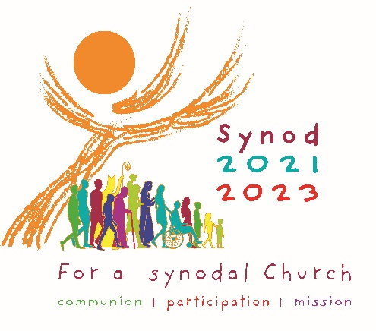
ELEMENTARY AGE LISTENING SESSION CLASS REPORT FORM
Based on the responses from the small groups during the share and listen time, what was particularly significant (repeated often), surprising or unexpected from the reflections? Which stories or experiences were especially moving and why? What new perspectives opened up? What tensions or disagreements emerged?

What are the 2 or 3 emerging actions the class felt called to take to grow in as a church family (grow in synodality)?

Demographic Information
Grade: __________ Age range of students: _____________________
Gender: Number of Boys ___________ Number of Girls ______________
Cultural self-identification of students: __________________________________________
What is the setting for this group?
School_______ PSR Program_______ Other________________________________
Number of Catholic Students: __________ Number of Non-Catholic Students: ____________
Name of Catholic School or Parish: _____________________________________________

